Protect Kids Using Parental control for Internet Access
Computer usage for online and offline activities opens a new world for information gathering, communication, commerce, productivity, and entertainment. It also presents new risks for predators, information disclosure, and easy access to inappropriate content in websites, messages, file downloads, and game and audio/video multimedia. For adults, the risks may be controlled by filtering technologies configured by an adult for his or her own account as self-filtering efforts.
Enforcing parental controls is different than self-filtering. Policies set by a parent or guardian must be enforced on dependents without the dependents being able to easily alter those policies. The same is true for tampering with activity logging information that may be essential for a parent or guardian to have sufficient information to set and maintain effective policies
Parental controls are features which may be included in digital television services, computer and video games, mobile devices and software.
Parental controls fall into roughly four categories: -
- Content Filtering:- which limit access to age inappropriate content;
- Usage controls:- which constrain the usage of these devices such as placing time-limits on usage or forbidding certain types of usage;
- Computer usage management tools:- which enforces the use of certain software;
- Monitoring :- which can track location and activity when using the devices.

Where can I set parental controls and what can I protect?

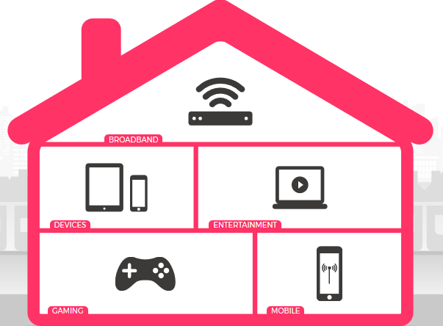
There are three levels of parental controls that you should be aware of:
 | Broadband & mobile networks | Devices :- | Entertainment & search engines
Prevents :- 1)access to age-inappropriate content  2) access to certain sites |  | Prevents access to  1)certain already downloaded apps  2) purchasing of new apps  3) downloading new apps  4) changes to privacy settings and password | Protects your child from  1) accessing age-inappropriate content  2) Shows content suitable for their age

Microsoft Family Security in Windows 10
Back in Windows 8 Microsoft introduced family security settings. These allowed parents to create children’s accounts, restrict the type of content they could access, as well as set time limits for when the young ones could use the devices. These still exist in Windows 10 and offer a good starting point for securing your PC.

Parental control softwares:-

Most parental control tools include content filtering—the ability to block access to websites matching unwanted categories such as porn, violence, and hate.

Access scheduling is another very common feature. Some applications let parents set a weekly schedule for Internet access, some control computer use in general, and some offer both as choice.

There are systems performing content filtering at the router level, so the settings affect every device on the network. This facilitates multiple device control with single s/w.

In Social Media Tracking the option to limit Childs view to posts and interactions that contain words or phrases that might indicate something inappropriate .In most cases, installation of social media tracking requires that you know your child's login credentials

With most parental control systems providing Remote Notification and Management, parents can opt to receive notification via text or email when the child tries to visit a blocked site, makes a post using iffy language, or otherwise bends the rules.

Parental control systems start to diverge, with many advanced features to help them stand out from the crowd. Some limit access to games, TV shows, and movies based on ratings. Some let parents control just who the kids can chat with via various instant messaging systems. Blocking specific applications is another advanced feature, as is forcing Safe Search on popular search portals

As per the review published at www.pcmag.com the best Parental Control Software for year 2017 are:-
- ContentWatch Net Nanny 7
- Symantec Norton Family Premier
- Circle With Disney
- Mobicip
- Kaspersky Safe Kids
- Qustodio Parental Control
- Clean Router
- OpenDNS Home VIP .

Note that these applications can't substitute for good communication. If you don't want your kids to visit certain kinds of sites, talk to them about your concerns. And do take time to convince older kids that you'll respect their privacy while monitoring their online actions. Otherwise, you can be sure they'll find ways to evade even the most sophisticated system.

