Configuration of Zyxel Line Bonding Modem ( Model- P-663HN-51 )
Step No. 1] Open router page
Http://192.168.1.1
Username:- admin
Password :- 1234
You will get following screen
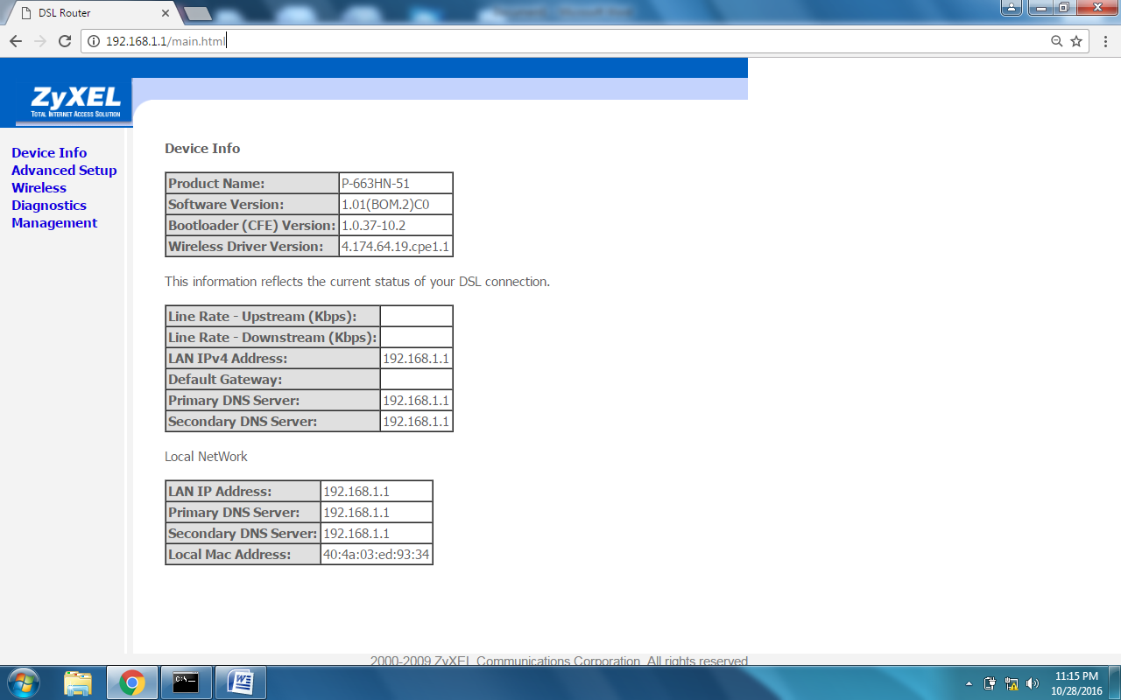
Step No. 2] Click on Advance Setup
You will get following screen
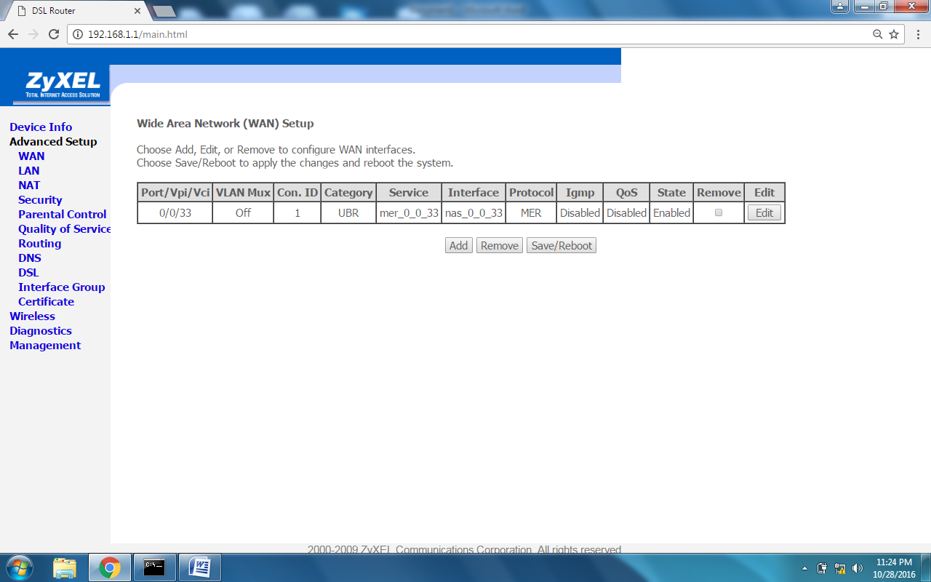
Tick mark under Remove and click on Remove button to remove default WAN interface setting.
And you will get screen as below-
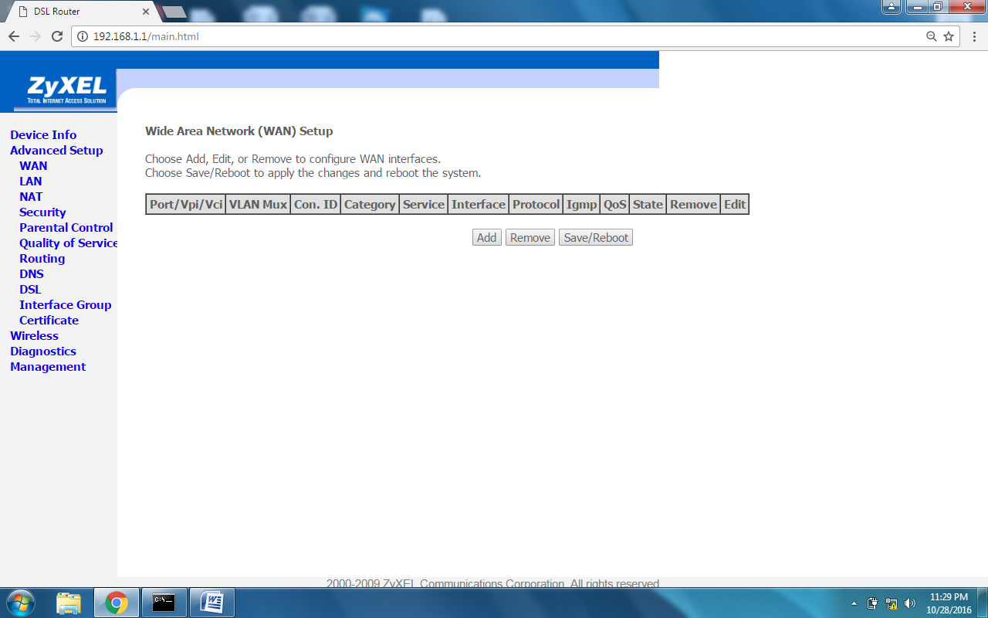
Step No. 3] Creating and configuration of WAN interface
Click on ADD button
You will get screen as below-
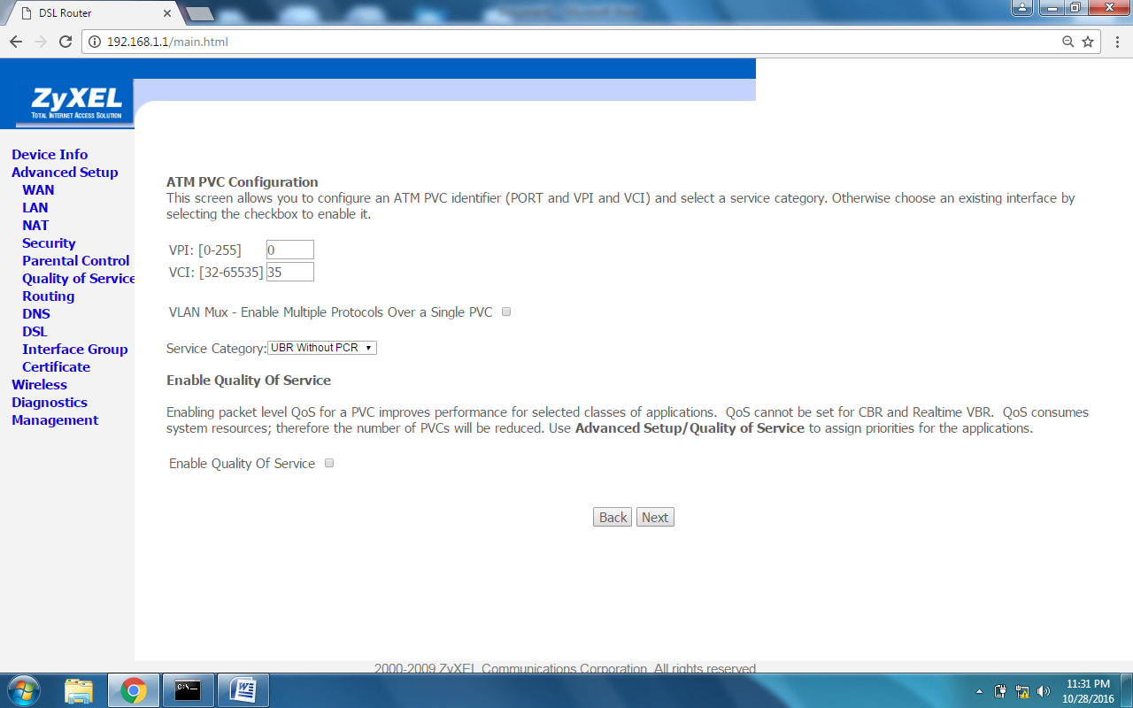
Change the value of VCI
VPI 0 and VCI 32 and click on Next button
You will get screen as below-
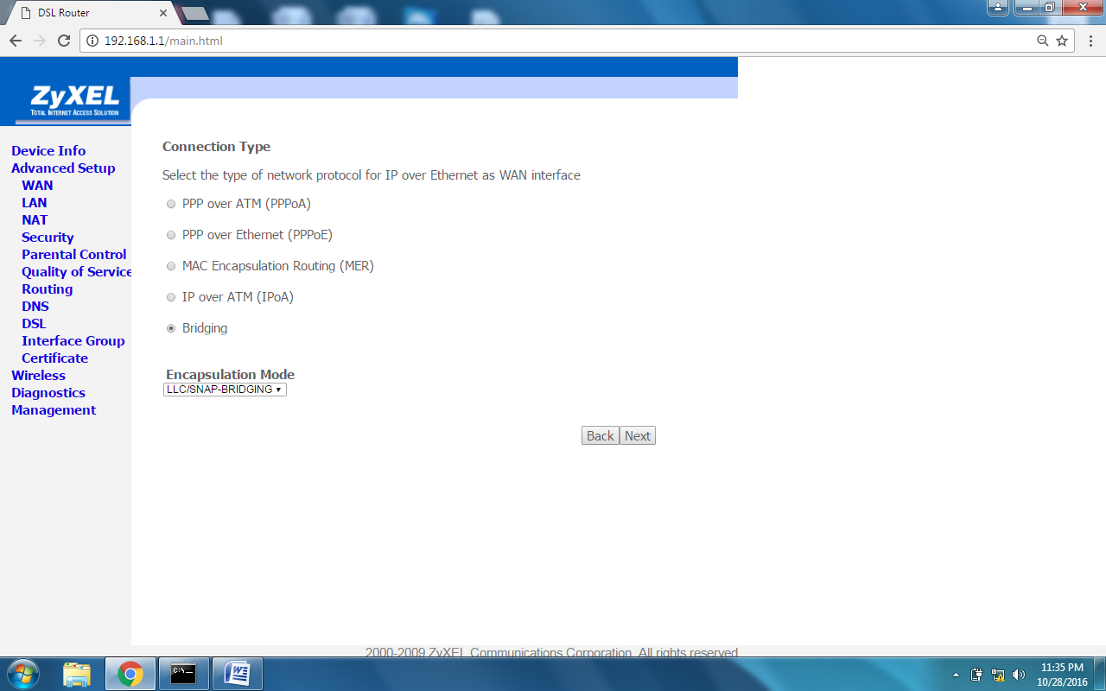
Select PPP over Ethernet (PPPoE), Change MTU value as 1492 and click on Next button
You will get screen as below-
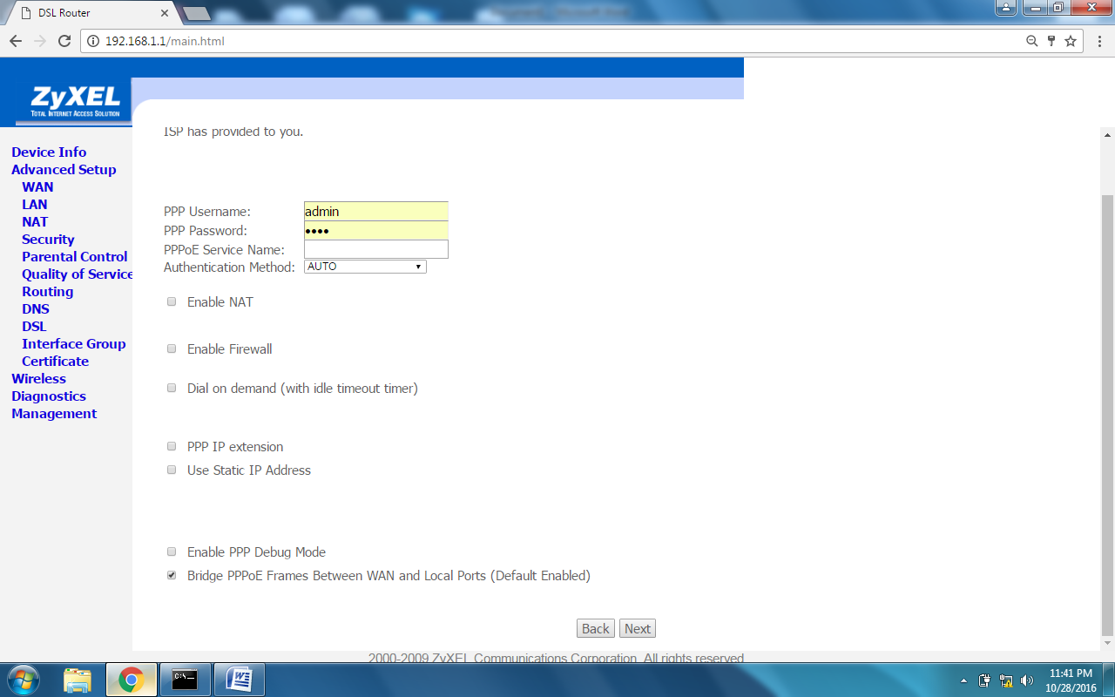
Enter Username as Telephone no. with suffix @a
Password as Customer’s CA no.
Tick mark on Enable NAT
Click on Next button
You will get screen as below-
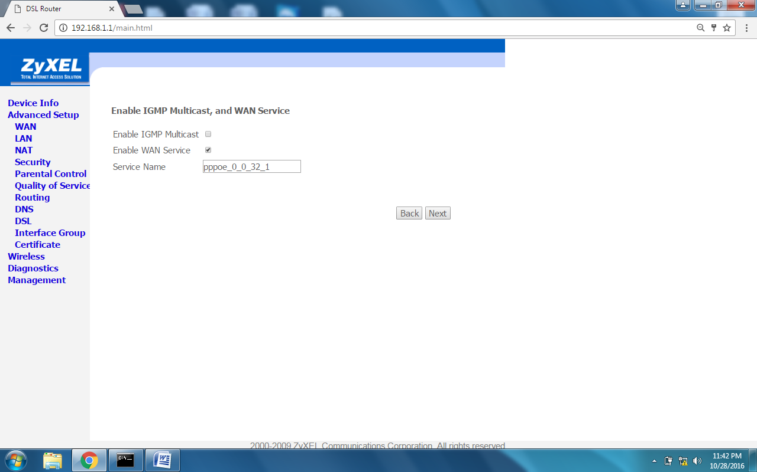
No change at this stage simply Click on Next button
You will get screen as below-
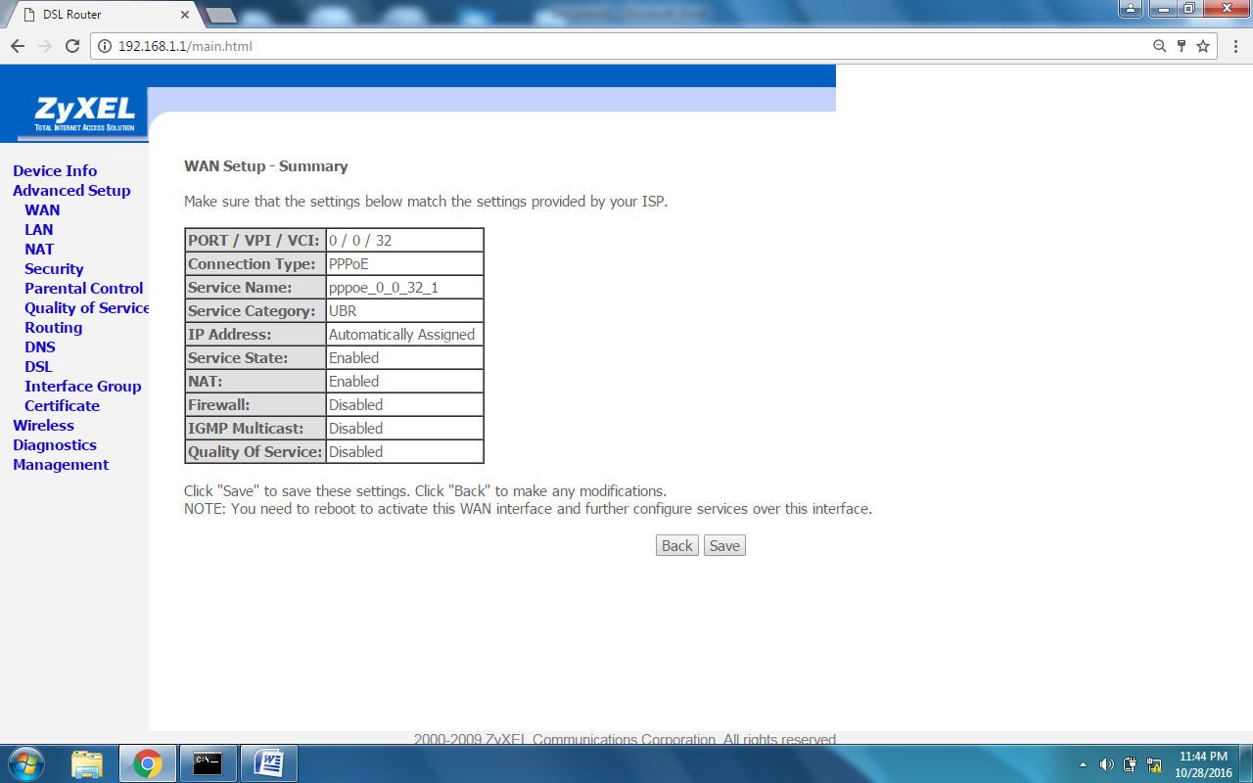
Click on Save button.
You will get screen as below-
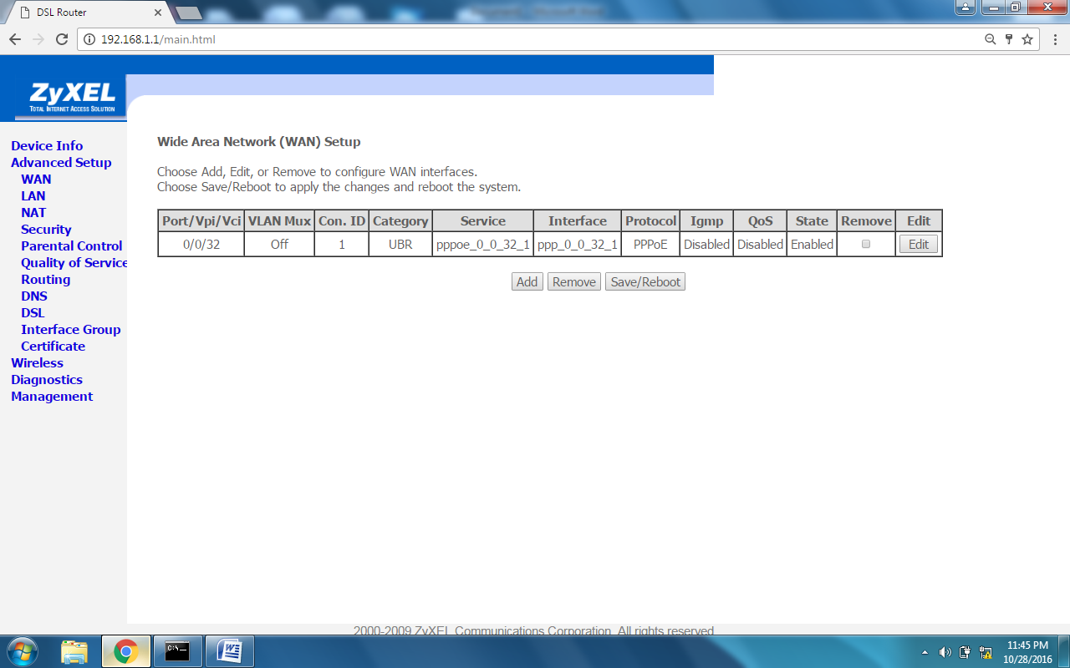
Click on Save and Reboot button
Now router is rebooting please wait
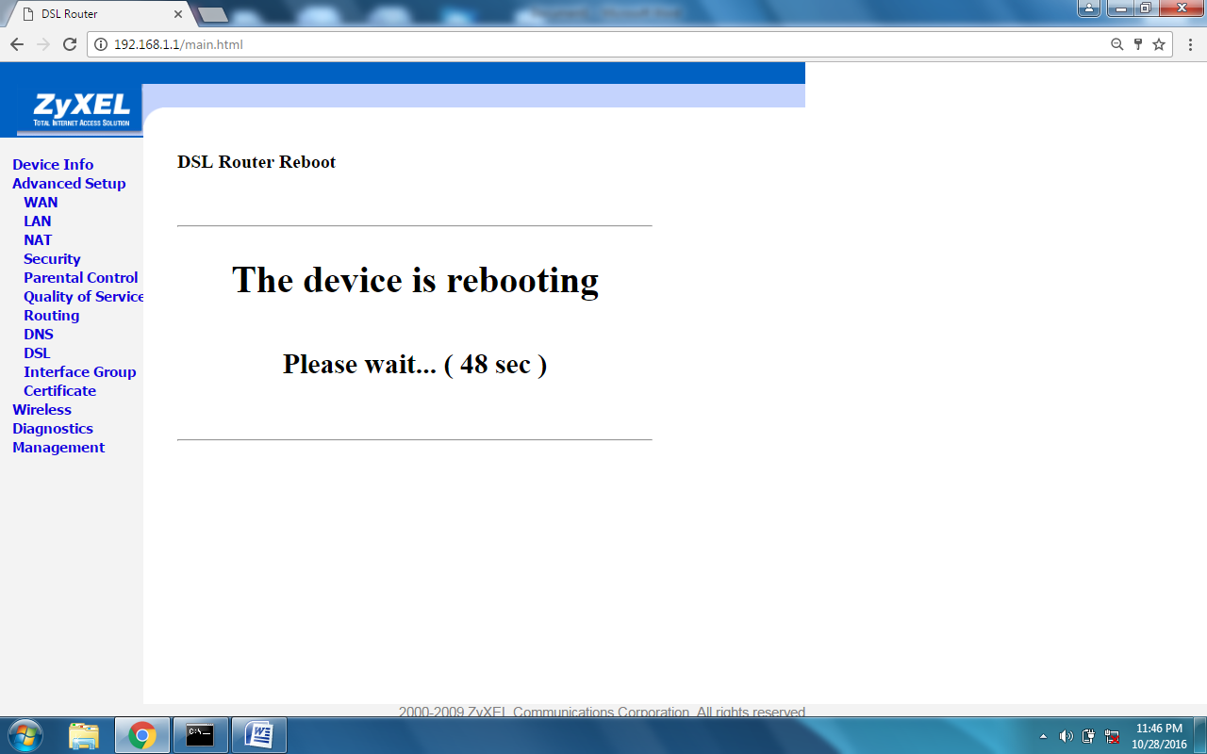
Step no. 4] Wireless setting
Click on Wireless
You will get screen as below-
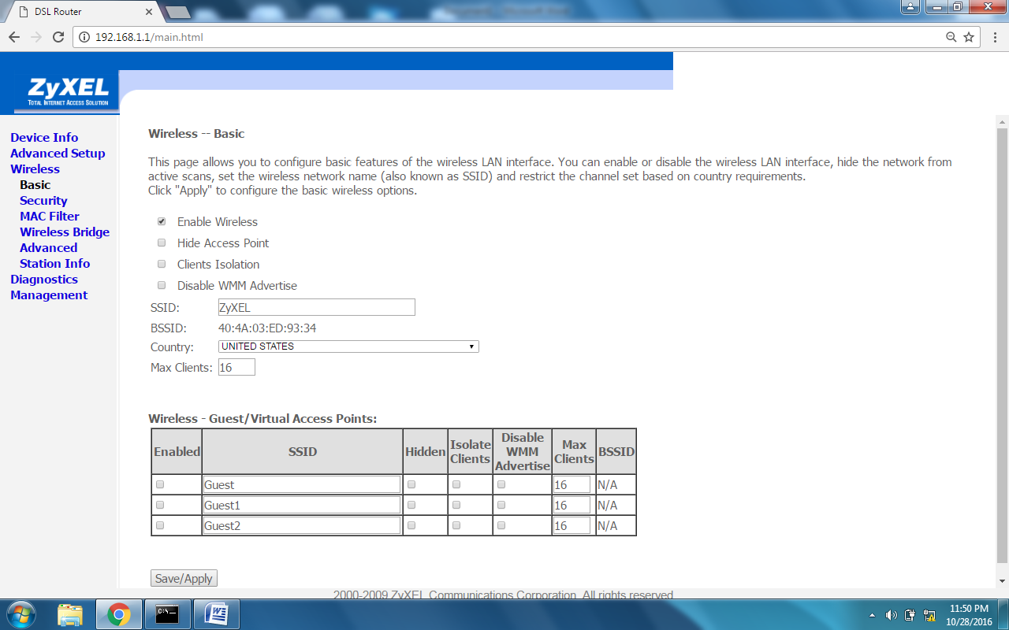
Click on Security
You will get screen as below-
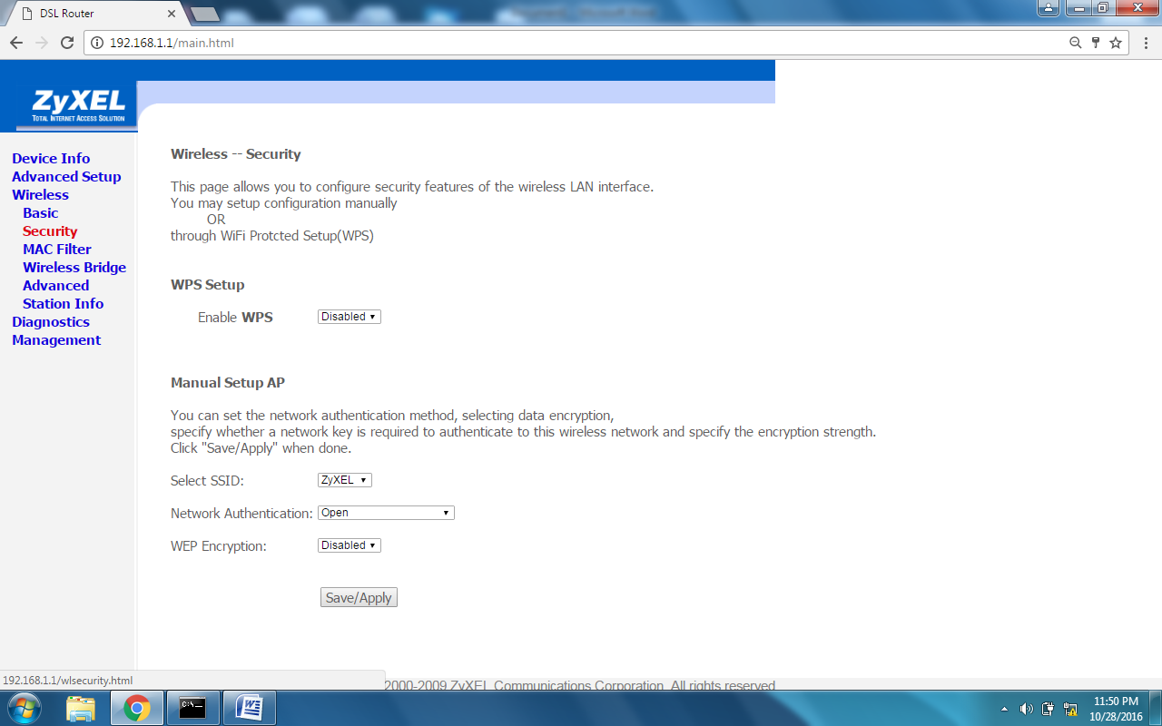
Select Network Authentication: as WPA2-PSK
WPA pre-Shared Key: [ password must be minimum 8 ASCII character e.g. asedf!@6]
WPS Encription: as TKIP/AES
Click on Save/Apply button
StepNo. 5] Save and Reboot configuration
Click on Management
Click on Save/Reboot
Click on Save/Reboot button
Now Router is rebooting. Wait for 2 minute.
Step No. 6] Restore Default Setting
Click on Management
Click on Setting
Click on restore Default Setting button

DE BB HD
MTNL MUMBAI
29-10-2016.

